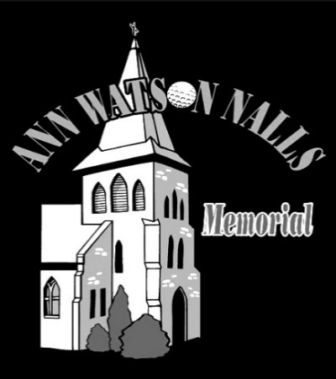 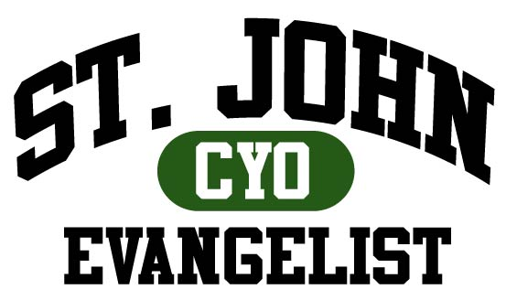

**Join us Friday June 1st at Hampshire Greens**

***proudly presents the***

**19th Annual St. John the Evangelist Parish   
MEMORIAL GOLF TOURNAMENT  
In Memory of ANN WATSON NALLS**

Dear Friends:

We're hoping you and your friends and family can join us for a great day of golf with your friends and family members from the entire St. John the Evangelist parish community. This year marks the 19th anniversary of the tournament that benefits the families of St. John’s. Anyone is welcome to play regardless of skill level! Come out and enjoy the FUN!

**The money raised through the golf tournament supports both the St. John the Evangelist parish community and the St John the Evangelist CYO Program on a 50/50 split.**

**This year’s tournament will be at Hampshire Greens Golf Course, which features a great staff, terrific clubhouse facilities, top-notch catering and a challenging layout that will be ready for Friday June 1st.**

**The schedule of events:**

**8:30 Registration**

**9:00 am Shotgun start**

**2:00-4:00 pm Patio barbecue, prizes & awards**

**The tournament fee has been reduced to $125, and includes 18 holes of golf, cart, dinner, drinks, door prizes, tournament souvenirs and more. If you sign up as a foursome, the cost drops to $450 so find your ringers and get a foursome.**

If you cannot make it to Hampshire Greens, please consider supporting through a sponsorship or donation of an item (i.e. gift cards, memorabilia) for the raffle/door prizes. The various sponsorships account for nearly 100% of the Tournament proceeds. All sponsors will be recognized with a placard and will be recognized at the tournament.

Thanks in advance for your kind support. We look forward to seeing you at Hampshire Greens on June 1st.

*The Ann Watson Nalls Memorial Golf Committee*

**ST. JOHN THE EVANGELIST PARISH GOLF TOURNAMENT  
IN MEMORY OF ANN WATSON NALLS**

**Friday June 1, 2018 Registration/Sponsor Form. Please return by May 29th**

$125.00 Tournament Player Name __________________________

$450.00  Tournament Foursome

Playing with ________________________________________

$25.00 I cannot play but will attend the evening barbecue.

**SPONSORSHIP OPPORTUNITIES AMOUNT ENCLOSED**

**All sponsors will be recognized with a placard and the tournament program**

$1,500.00 Tournament Sponsor (includes 4some, hole placard) _________

$600.00 Hole-In-One Sponsor _________

$300.00 Beer Station Sponsor _________

$300.00 Driving Range Sponsor _________

$250.00 Closest-To-Pin Sponsor _________

$250.00 Longest Drive Sponsor _________

$100.00 Hole Sponsor _________

$50.00 Golf Cart Sponsor _________

In Kind Donation ______________________________________________________

Name as it should appear for sponsorship ____________________________________

*We thank you for your support! Questions contact Kevin Carey @ 202-236-6792 or* [*kdcarey@loyola.edu*](mailto:kdcarey@loyola.edu)

*Ann Watson Nalls Memorial Golf Tournament*

*St. John the Evangelist*

*10103 Georgia Avenue*

*Silver Spring, MD 20902*Register online or make a donation as a sponsor, go to: <https://jes.ejoinme.org/2018SJEGOLF>